Create UML diagrams for an online library system that has two users a guest and a member.

The main web page will display a list of available books that can be filtered into three distinct categories.

The page will look like this there will be some CSS tricks that will change the content when the mouse hovers over a card.

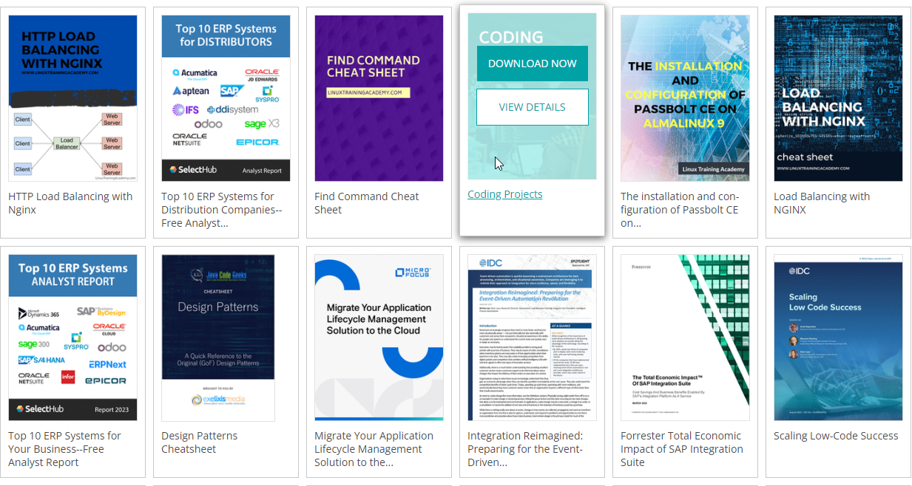

Each card will be dynamically generated using ES6 Class construct and styled using CSS flexbox.

There will be a login facility that will allow a new member to register on to the system the database will be MySQL. The member will use an email address as a primary key the member will need to supply a password that contains the following constraints.

* Minimum of 5 characters maximum of 10.
* Contain at least 1 Capital letter.
* Contain at least 1 numeric character.
* Contain at least 1 special character.

The member when logging in will be able to select books that have already been seen by themselves.

The member can choose between three separate categories of books and a book can belong to more than one category.

* Create the UML for this system that contains a maximum of 5 Use Cases.
  + Use the template on Moodle for the USE-CASE Description.
* Create a Sequence Diagram for the System.
* Create a Class Diagram for the Creation of a CARD containing the following information.
  + Title Author Category image URL.
* Create a wireframe for the proposed Web Page.
* Create an ERD diagram for the Member, Book, Library, Category and any other Tables as required.